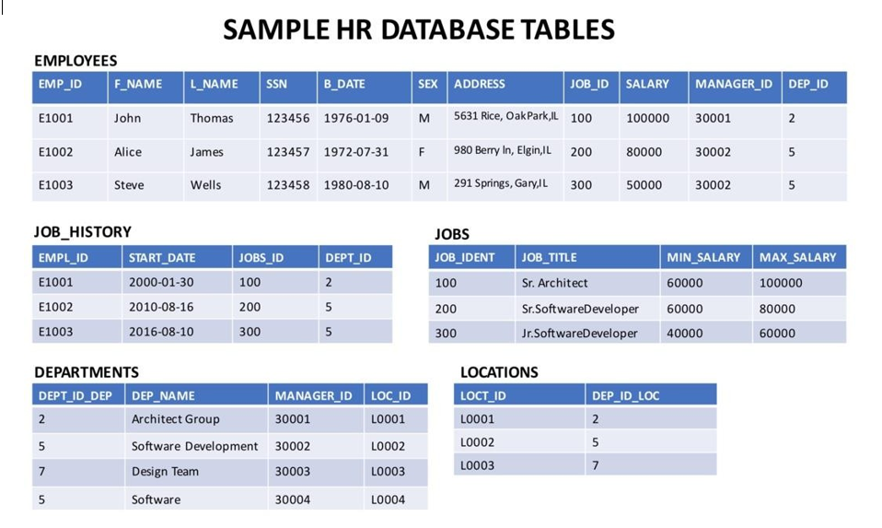

Problem:

Select the names and job start dates of all employees who work for the department number 5.

Solution:

**select** E.F_NAME,E.L_NAME, JH.START_DATE

**from** EMPLOYEES **as** E

**INNER** **JOIN** JOB_HISTORY **as** JH **on** E.EMP_ID=JH.EMPL_ID

**where** E.DEP_ID ='5';

Problem:

Select the names, job start dates, and job titles of all employees who work for the department number 5.

Solution:

**select** E.F_NAME,E.L_NAME, JH.START_DATE, J.JOB_TITLE

**from** EMPLOYEES **as** E

**INNER** **JOIN** JOB_HISTORY **as** JH **on** E.EMP_ID=JH.EMPL_ID

**INNER** **JOIN** JOBS **as** J **on** E.JOB_ID=J.JOB_IDENT

**where** E.DEP_ID ='5';

Problem:

Perform a Left Outer Join on the EMPLOYEES and DEPARTMENT tables and select employee id, last name, department id and department name for all employees.

Solution:

**select** E.EMP_ID,E.L_NAME,E.DEP_ID,D.DEP_NAME

**from** EMPLOYEES **AS** E

**LEFT** **OUTER** **JOIN** DEPARTMENTS **AS** D **ON** E.DEP_ID=D.DEPT_ID_DEP;

Problem:

Re-write the previous query but limit the result set to include only the rows for employees born before 1980.

Solution:

**select** E.EMP_ID,E.L_NAME,E.DEP_ID,D.DEP_NAME

**from** EMPLOYEES **AS** E

**LEFT** **OUTER** **JOIN** DEPARTMENTS **AS** D **ON** E.DEP_ID=D.DEPT_ID_DEP

**WHERE** YEAR(E.B_DATE) < 1980;

Problem:

Perform a Full Join on the EMPLOYEES and DEPARTMENT tables and select the First name, Last name and Department name of all employees.

Solution

**select** E.F_NAME,E.L_NAME,D.DEP_NAME

**from** EMPLOYEES **AS** E

FULL **OUTER** **JOIN** DEPARTMENTS **AS** D **ON** E.DEP_ID=D.DEPT_ID_DEP;

Problem:

Re-write the previous query but have the result set include all employee names but department id and department names only for male employees.

**select** E.F_NAME,E.L_NAME,D.DEPT_ID_DEP, D.DEP_NAME

**from** EMPLOYEES **AS** E

FULL **OUTER** **JOIN** DEPARTMENTS **AS** D **ON** E.DEP_ID=D.DEPT_ID_DEP

**WHERE** E.SEX = 'M';